Name: Ningyuan Zhang

Section: A

Date: 3/30/2017

Instructor: Akhilesh Tyagi

Project A

outputs of main control:

o_reg_dest; -- ‘1’ write to rd, ‘0’ will not

o_jump; -- ‘1’jump flag as selector of 2 to 1 mux, ‘0’ select 0 value

o_branch; -- ‘1’jump flag as selector of 2 to 1 mux, ‘0’ select 0 value, will and with ALU zero flag

o_mem_to_reg; -- write ALU output to reg file or not

o_ALU_op; -- operation code in ALU

o_mem_write; -- write to memory or not

o_ALU_src; -- select immidiate data as second input to ALU or rt data

o_reg_write; -- write enable to write register file (write rd)

load $t0, 0($zero):

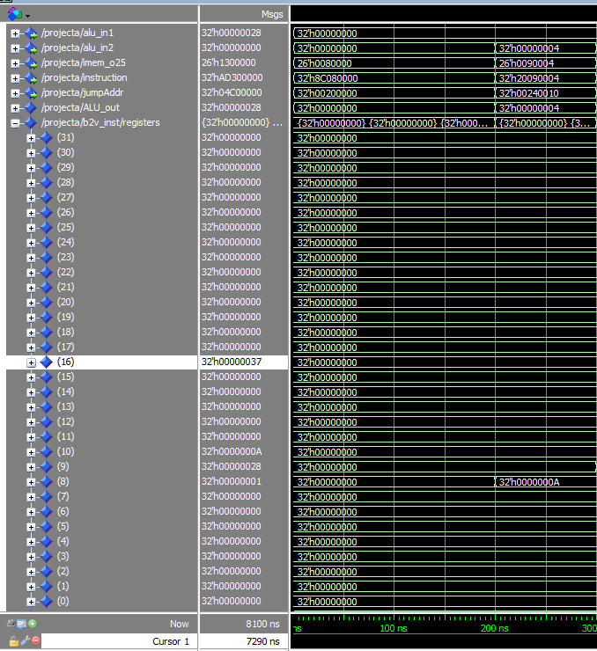

addi $t1, $zero, 4:

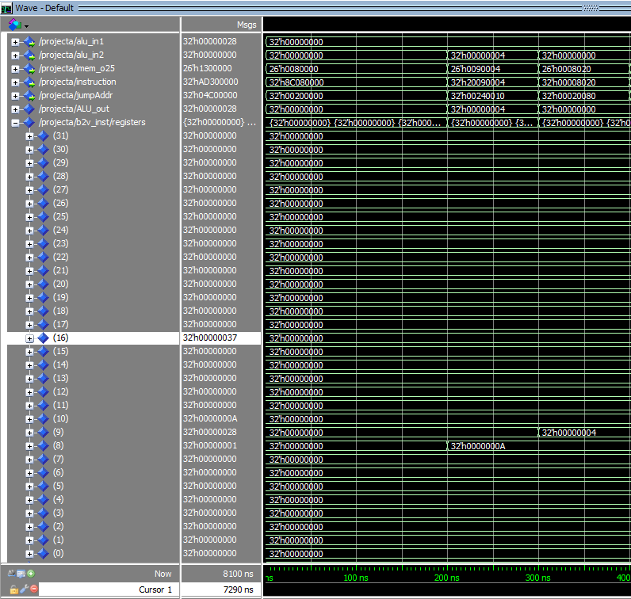

add $s0, $zero, $zero; j check:

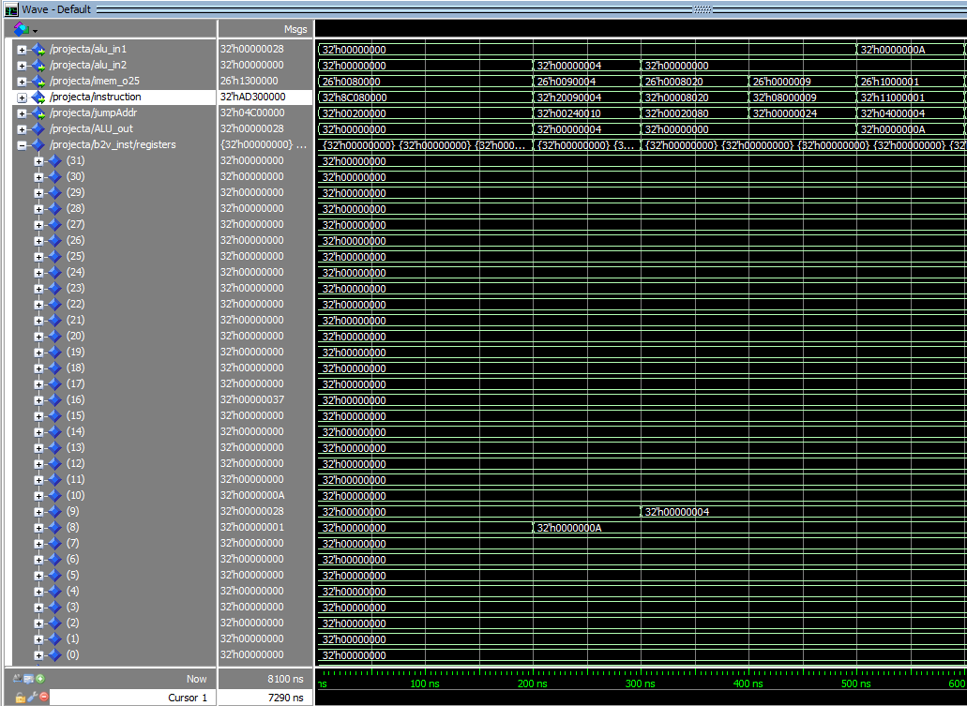

first time run sw $s0, 0($t1):

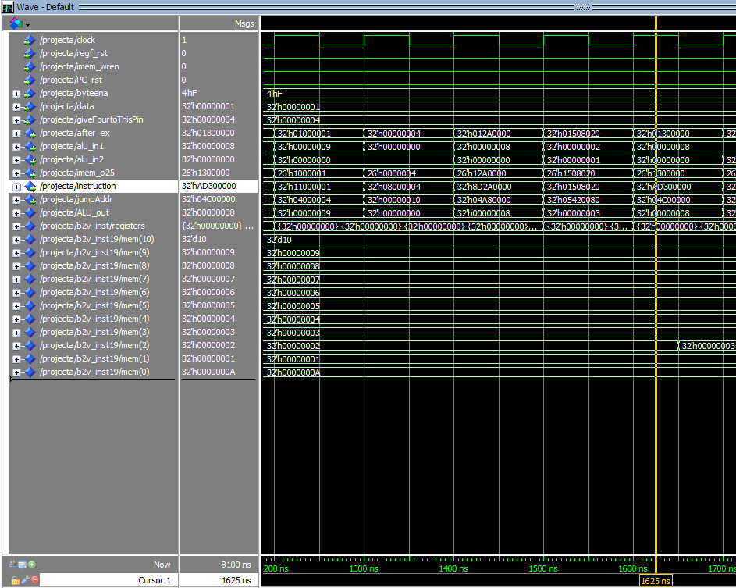

result from mars:

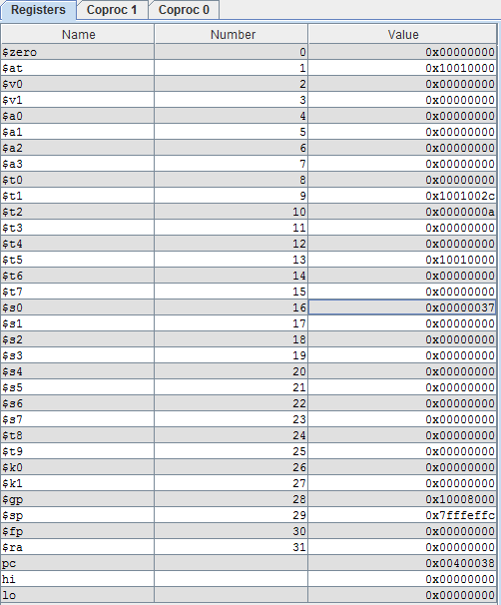

result in wave form:

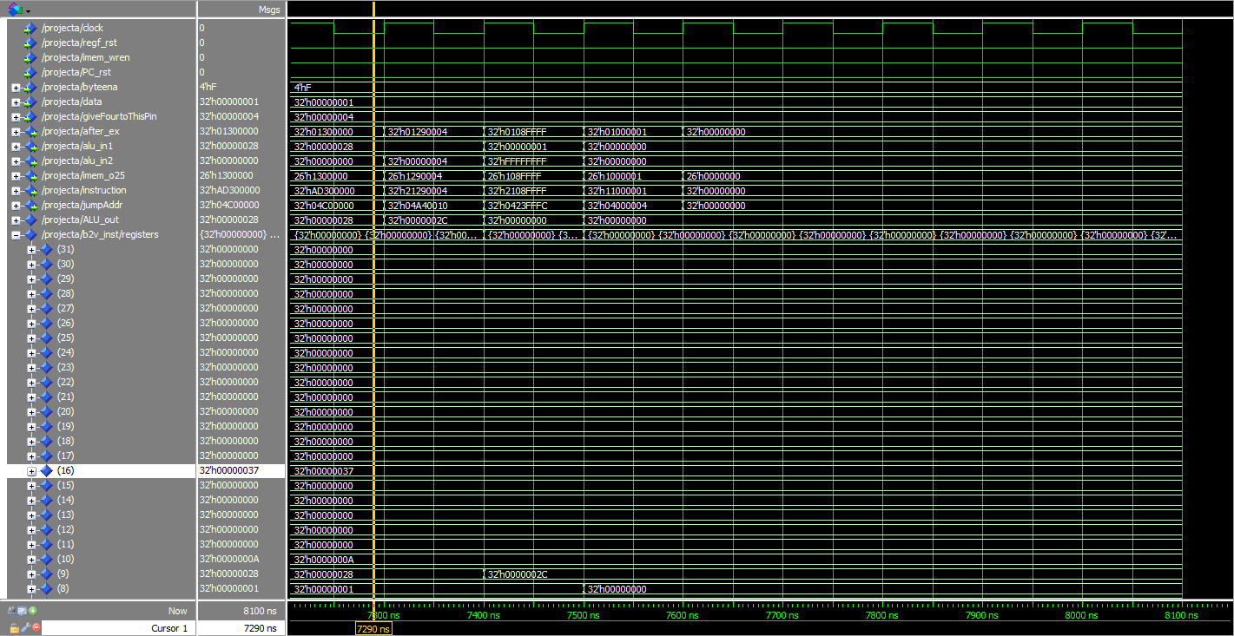

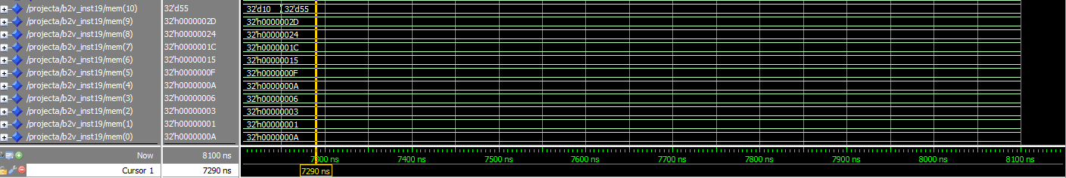

vhdl file named projectA.vhd

during this lab I created the component jumpAddrGnrt and 26 to 32 bit extender. I also added monitoring signal outputs to monitor the values.